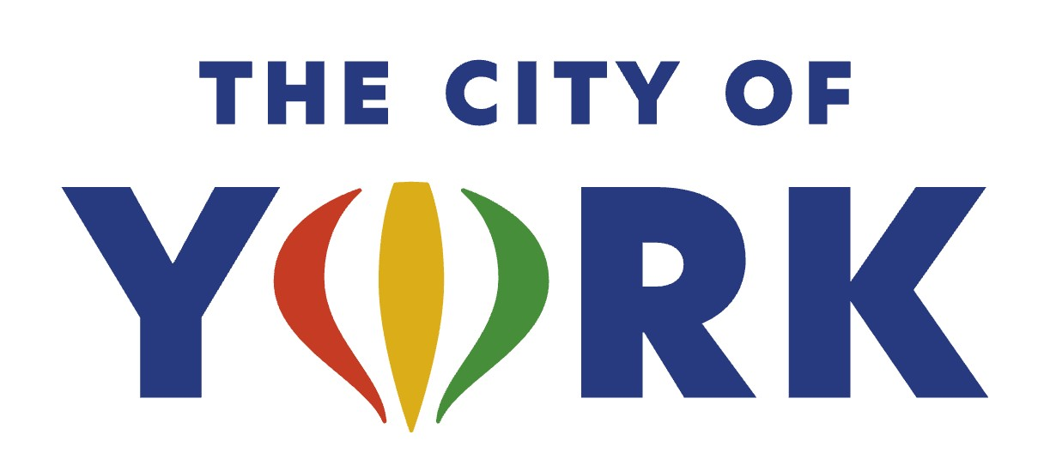

Library Director – Kilgore Memorial Library

**Now Hiring: Library Director
Kilgore Memorial Library – York, Nebraska**

Are you a visionary leader who believes in the power of libraries to transform communities? The City of York, Nebraska is seeking an innovative, strategic, and community-minded Library Director to guide our library into its next exciting chapter.

As a key executive leader for the City of York, the Library Director provides strategic direction, champions a culture of learning and service, and ensures that our library remains a dynamic, welcoming, and future-focused resource for all. This is an outstanding opportunity for an experienced professional who thrives on collaboration, innovation, and meaningful community engagement, including engagement and public involvement with elected officials, other policy makers and citizens; and serve as a member of the York Senior Leadership Team.

What You’ll Do
As the Library Director, you will:
- Shape the future of Kilgore Memorial Library through long-range planning, policy development, and alignment with municipal goals.
- Lead a talented team by fostering professional growth, supporting staff development, and cultivating a positive and high-performing workplace culture.
- Manage all aspects of library operations—from budget planning and resource allocation to program development and collection strategies.
- Champion technology initiatives, ensuring our digital services, systems, and data-security practices remain cutting-edge and responsive to community needs.
- Build strong community partnerships, represent the library in public forums, and serve as an enthusiastic ambassador for library services.
- Participate at the executive level through board service, city management teams, and regional professional networks.
- Uphold compliance with local, state, and federal standards while ensuring operational excellence across all departments.

What We’re Looking For
We’re seeking an inspiring leader with:
- A Master’s Degree in Library Science from an ALA-accredited institution.
- Demonstrated experience in leadership, strategic planning, fiscal management, technology oversight, and community engagement.
- Strong communication, team-building, and problem-solving skills.
- A passion for public service and a commitment to serving a diverse and growing community.
- Bilingual proficiency in English and Spanish is a plus.

Why Join Us?
Kilgore Memorial Library is a cornerstone of the York community—an energetic, forward-thinking organization supported by engaged residents, a dedicated City leadership team, and active partner organizations including the Library Foundation and Friends of the Library. As Library Director, you will have the opportunity to shape impactful programs, embrace emerging technologies, and lead a team committed to exceptional service.

If you are ready to make a meaningful difference, inspire others, and lead a vibrant public library into the future, we want to hear from you!

The library director reports to the York City Administrator and is a member of the leadership team. The City of York provides a competitive salary based upon experience and qualifications, as well as an excellent benefit package. Salary range for the pay grade assigned to this position is $73,943 to $99,091. Applicant must be 18 years of age and authorized to work in the United States.

Apply online at www.cityofyork.ne.gov or email your application and resume to dpfeifer@cityofyork.ne.gov or mail to Denise Pfeifer, HR Director, 100 E. 4th Street, York NE 68467.

Applications will be accepted until the position is filled

City of York is an Equal Opportunity Employer

